Teston to Tonbridge via R Medway and Greensand Way
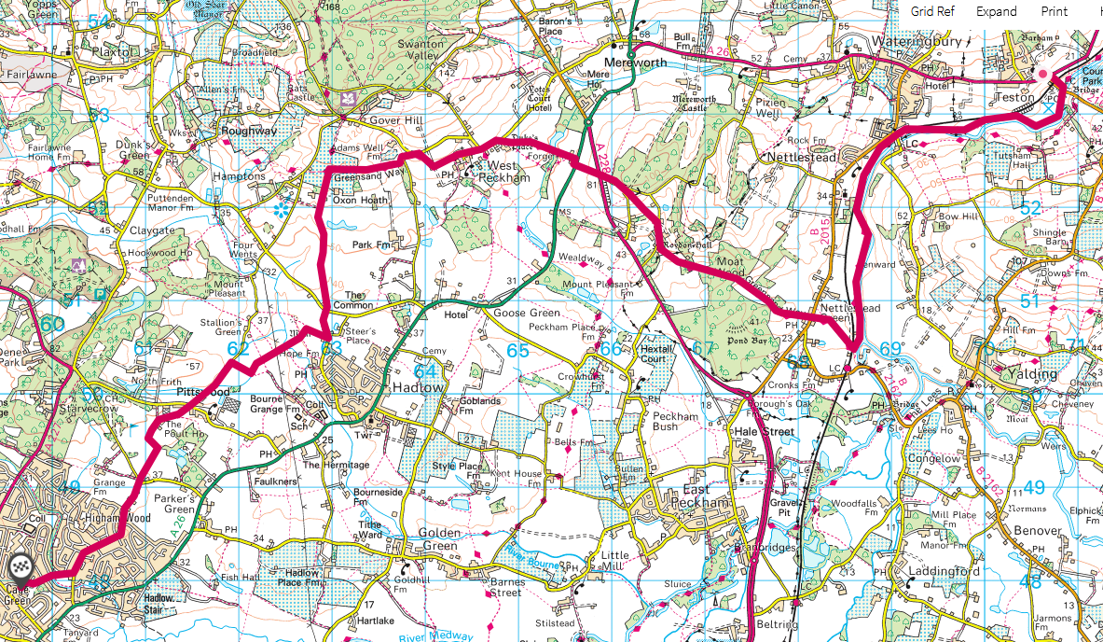
Overview map

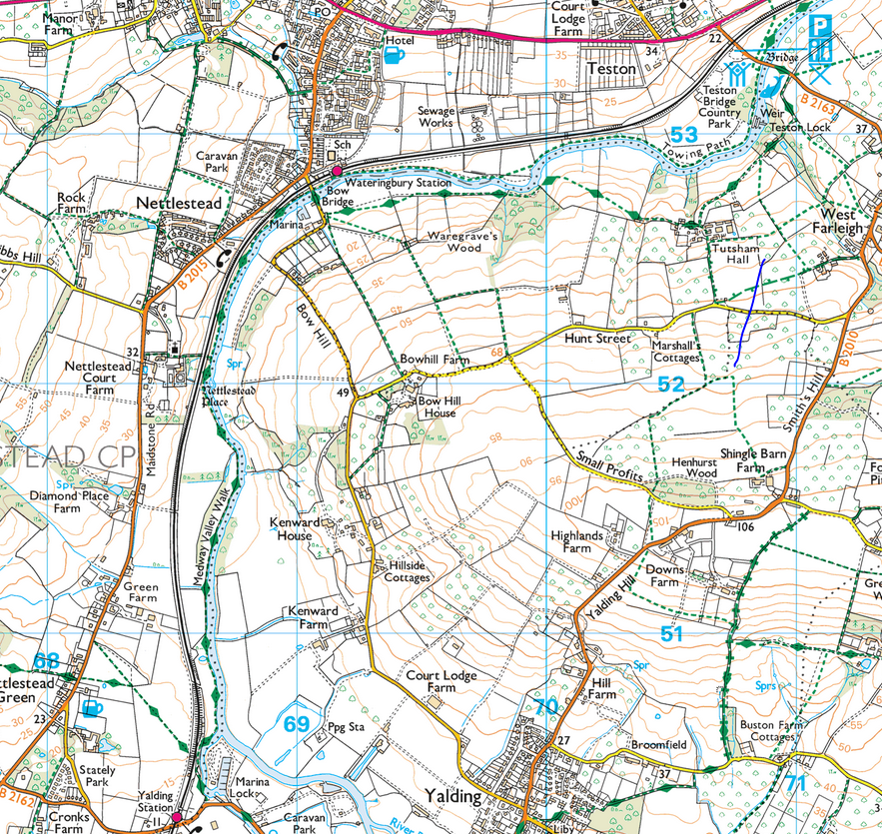Follow R on N bank to Yalding
Follow Greensand Way (N and W) to West Peckham. Church just past Roydon Hall is worth a look inside. 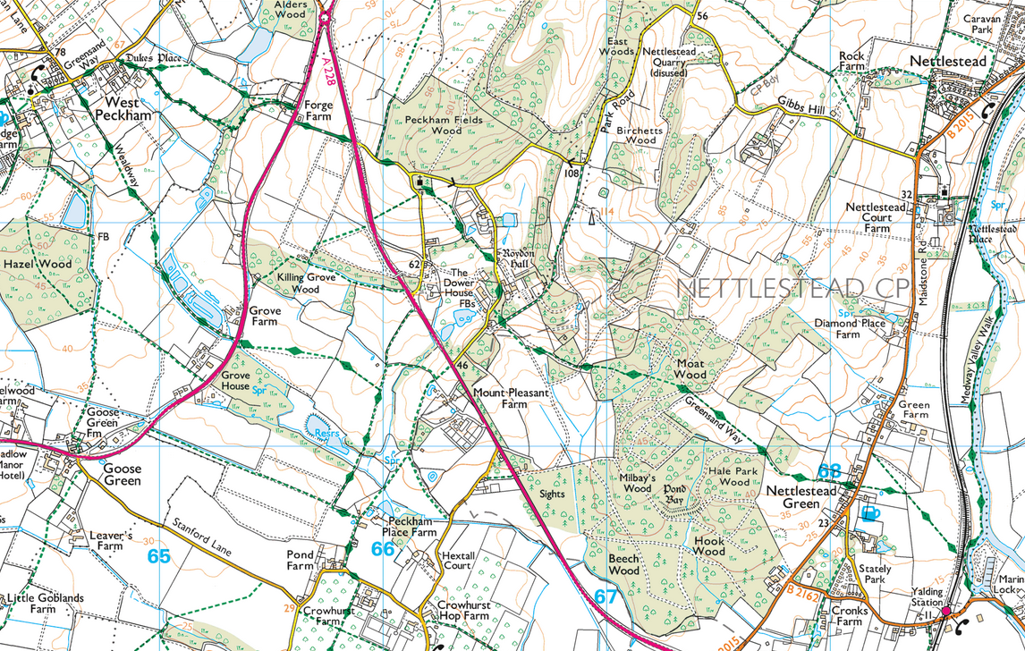
Follow Greensand Way to Oxen Hoath, then turn S through Oxen Hoath Park. At Steer’s place turn W
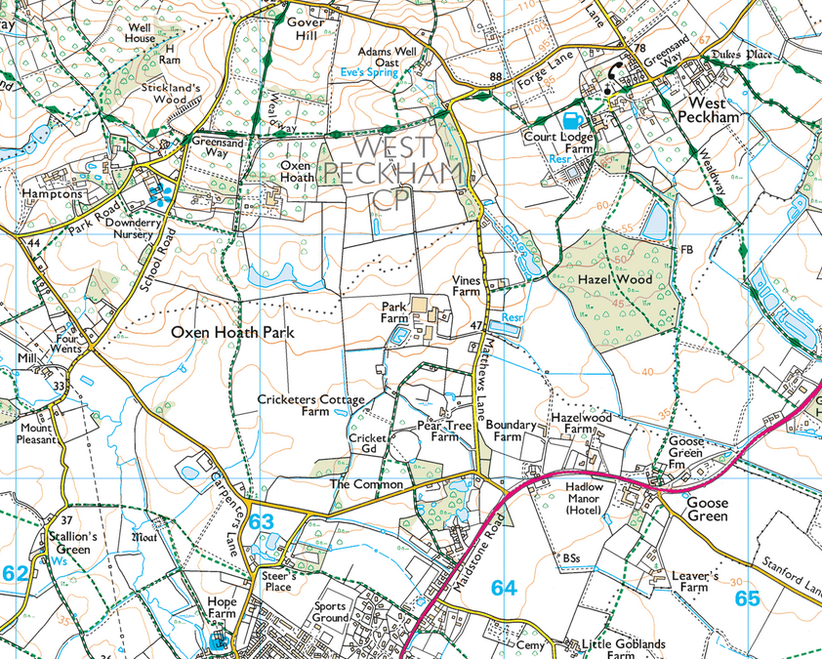
Make your way – zig-zag – to High House Lane. Cross Poult Wood Golf Course to Higham Lane – then home to St Phils or beyond.
