Muddy section

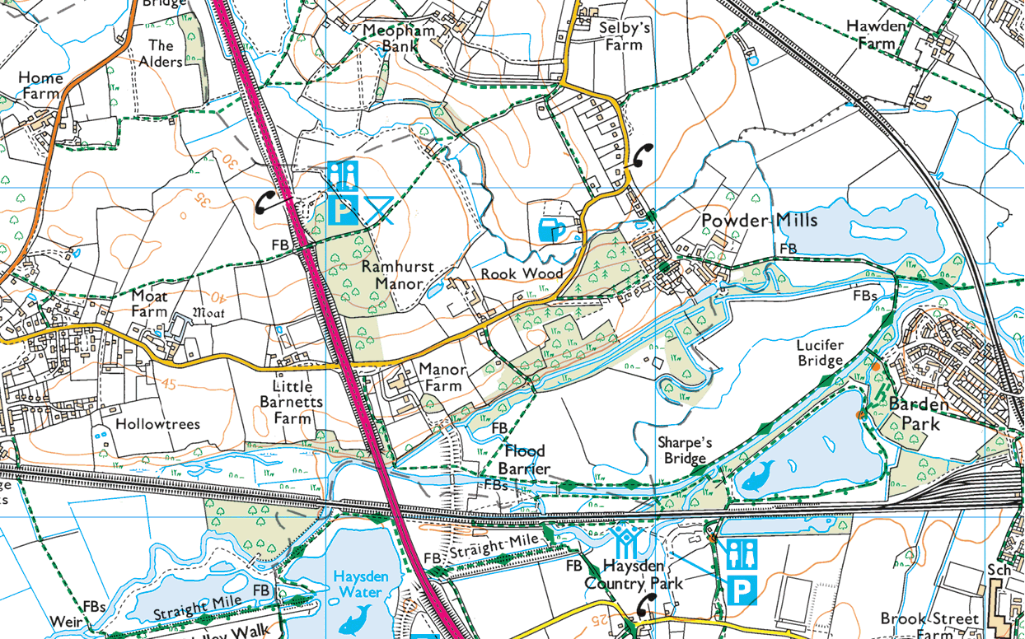

Turn here for home

OUT and home

Cross from river to road

IN from Park

IN from Park