Get 7 bus to Teston, walk down to bridge and follow River Medway on near bank to Nettlestead
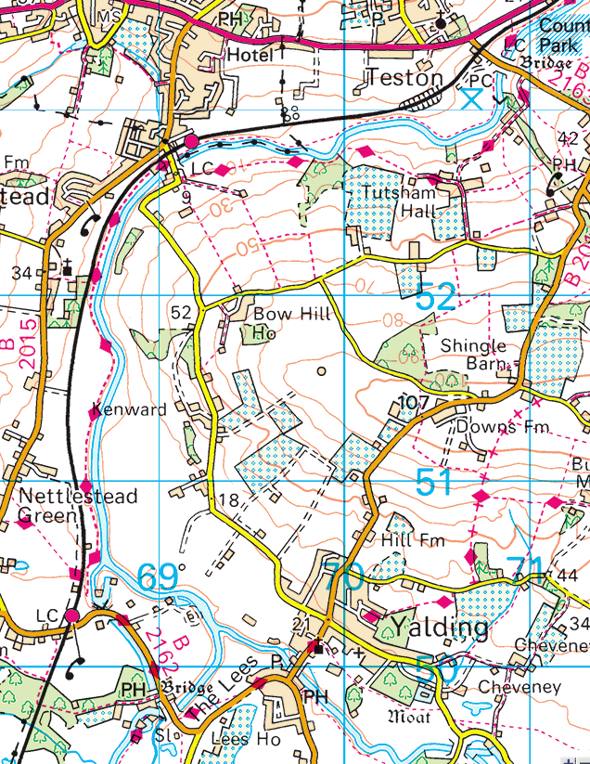
At Marina follow road to bridge by the Teapot Island. Cross to far side of river and…

Follow river on South side past East Peckham (Branbridges)
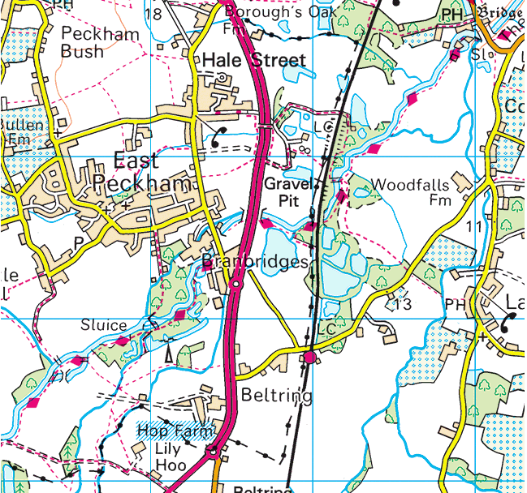

Stick to South bank until lock by island in middle of this map
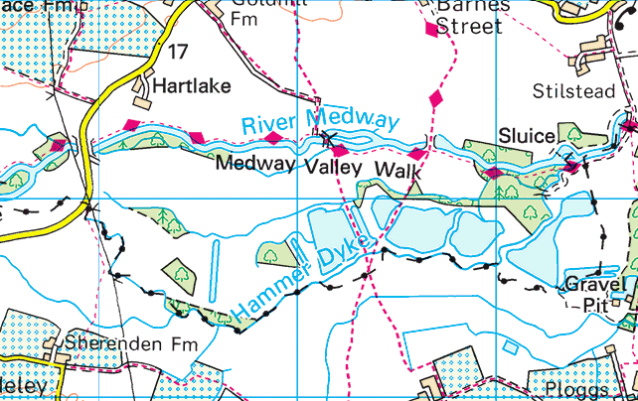
Swap to North bank to Hartlake Bridge
And continue past 2 more locks to come out on Cannon Lane in Tonbridge
