Park at Ightham Mote, and leave car park at footpath opposite entrance – Head north towards Raspit Hill
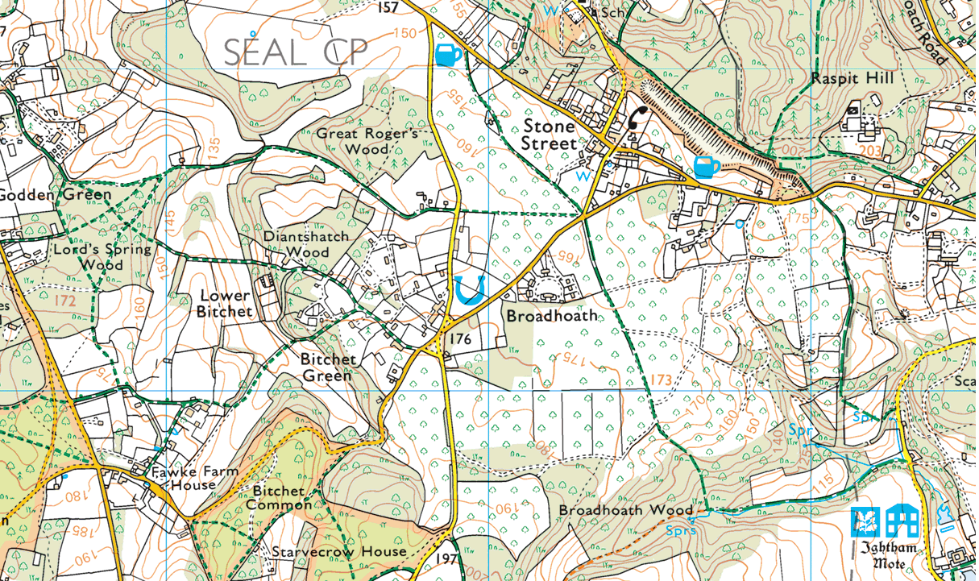

Shorter Route is to go along top of embankment above Stone Street and continue along ridge to spot height 176 in Redhill Wood, and along to turn L to ‘The Grove’. At Road (Oak Bank Hall) turn L again and bear R onto path (arrowed)
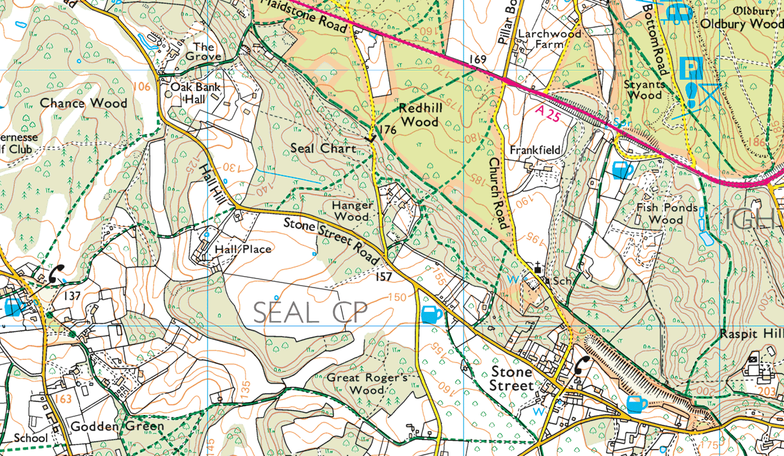

From pub on map take path SE, then E to Great Roger’s Wood, cross road and loop N of Broadhoath, then SSE to Broadhoath Wood, before turning E
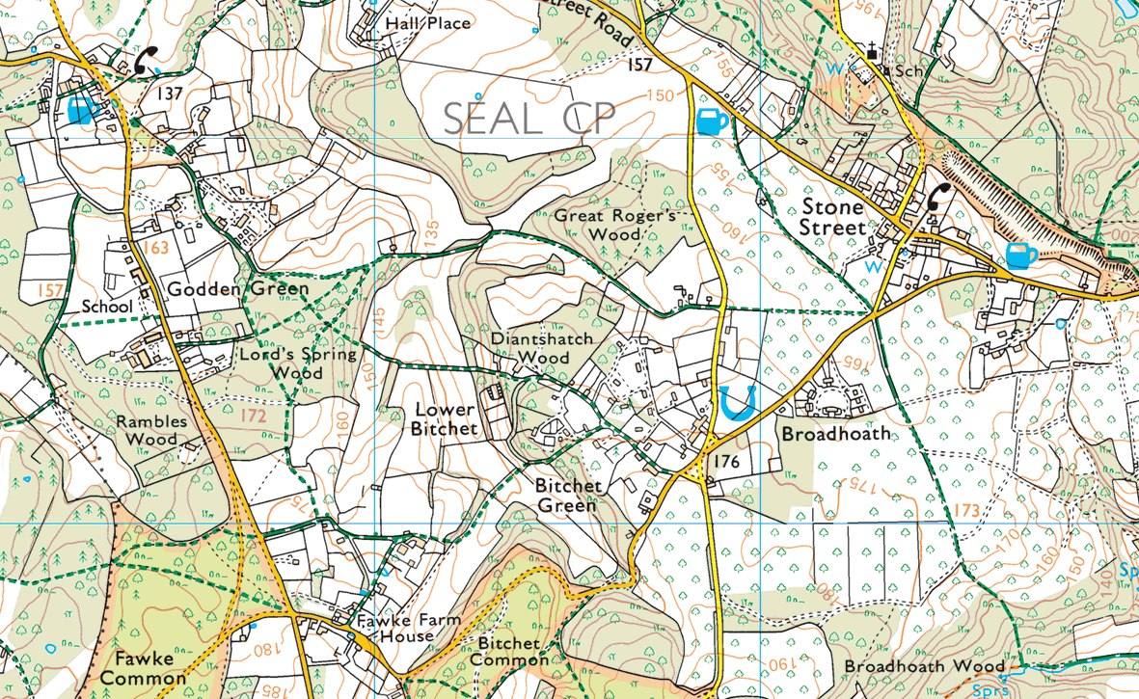
To finish at Ightham Mote (see map on page 1 again)

Longer Route includes Oldbury Hill – over the A25 – go over Raspit Hill and at A25 continue on road opposite – make your own way to top of Oldbury Hill on R , and work your way W crossing Pillar Box Road. Turn SW here to pick up shorter route via ‘The Grove’ and Old Bank Hall (see page 2 above) 