Three Churches Walk
Long Version (10 miles) – From Tonbridge See page 5 first.
Short Version (5 miles) – From Tudeley Church car park (optional £2) go out the back eastwards to Bank Farm. L at road and R onto path by horse paddocks
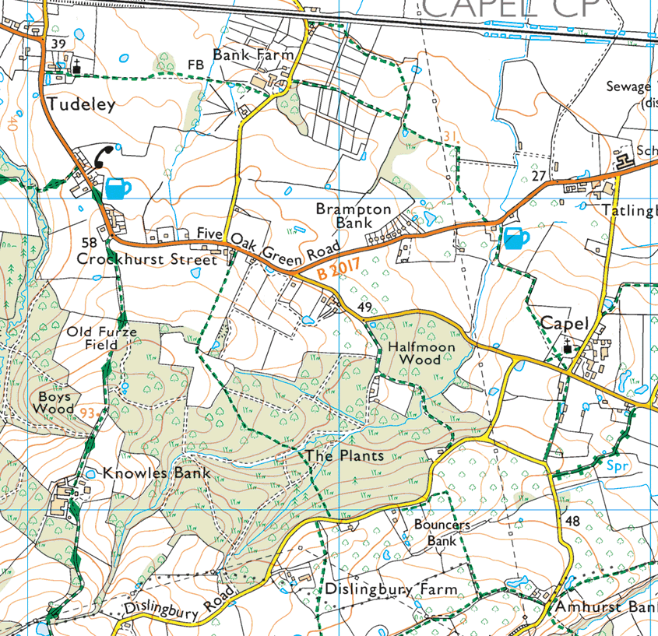
Cross B2017 at George and Dragon (L and R again) onto path to Capel Church

Page 2 - At Capel Church take bridle path across road (South) to reach Amhurst Bank Road and follow this for 1K until it falls sharply downhill.
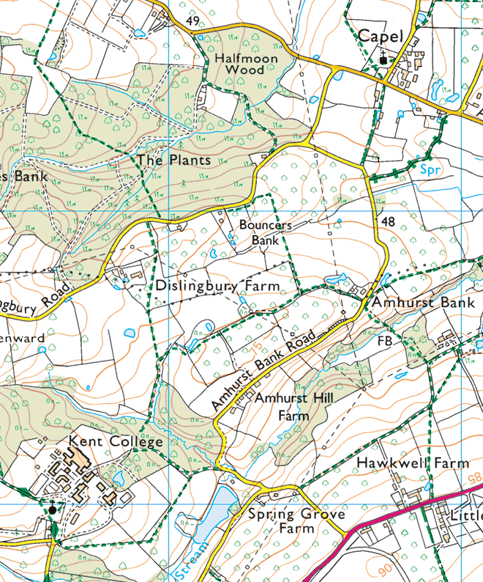
Just after bridge turn R (a bit muddy here) to take stile into field of sheep. Follow path SW and W to road just S or church at Kent College – nice bench in churchyard for coffee)

Page 3
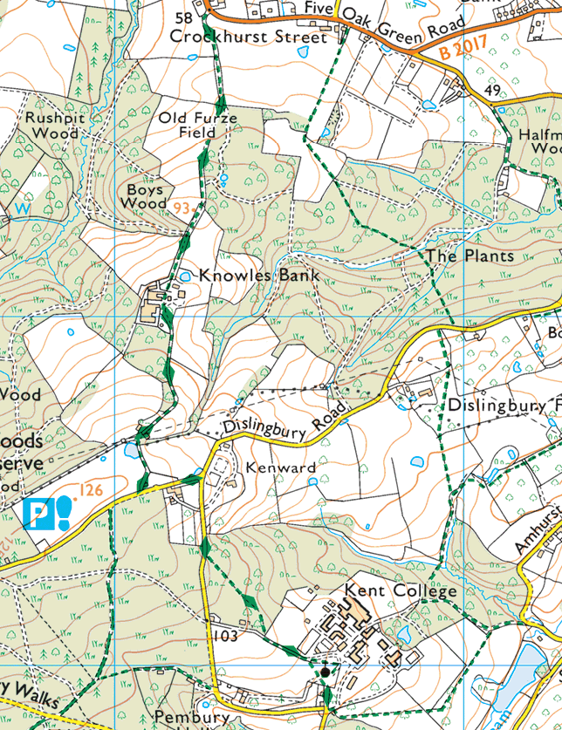
From gate at back of churchyard, turn L, and after 100yds turn R into woodland. Follow path NW through the wood to read road. Turn R. At junction turn L and after 200 yds turn R into driveway of Knowles Bank. Just before gates to the house, path takes detour round L hand side of the house (not as on the map above). Keep heading N until you reach road near Turmeric Gold

Page 4
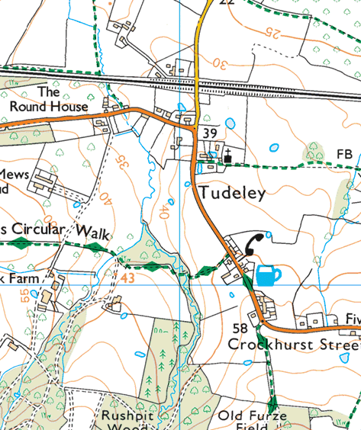
After Turmeric Gold, the path is on the L. Cross road and just after entrance to the path you can take ‘Permissive Path’ behind hedge which follows the road on W side back to opposite Tudeley Church car park. Its horrible trying to walk on or by the road here.
OR – follow path for 400 yards across stream until you reach driveway to farm here. Turn R and follow driveway N to road and then on the road back to the car park.
If you are doing the long option, follow ‘Circular Walk’ back to Somerhill School as below

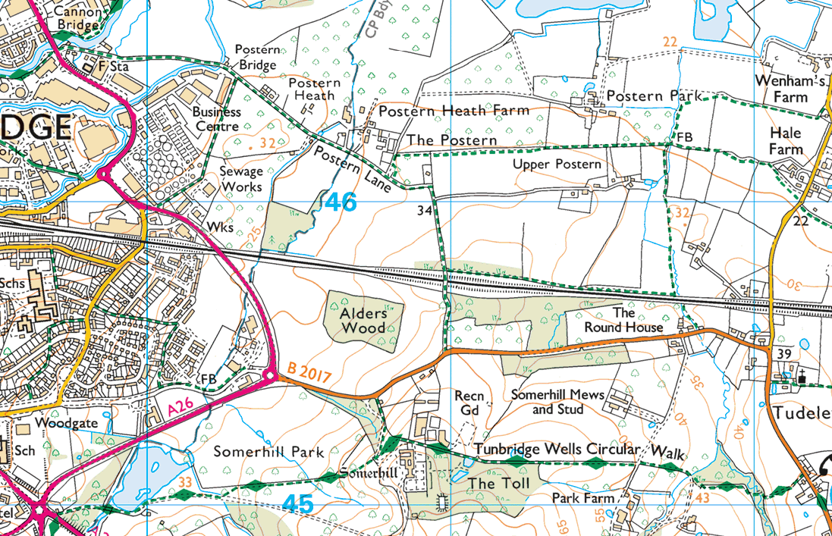
Long Version Out – Postern Lane and path to the road near The Poacher at Hale Farm – then R on road to Tudeley Church – then follow route from page 1
Long Version Home - Follow Circular Walk to Somerhill School – down main driver to road - R and L (with care) and into Postern Lane and back to Tonbridge

