Ide Hill to Emmetts to French Street to Toys Hill and back to Ide Hill – start at Ide Hill (bottom right) and follow instructions on this page anti-clockwise
Turn R and L onto path to French Street Out back of Emmets and onto road WSW Walk N to Cordon’s Farm then W along road
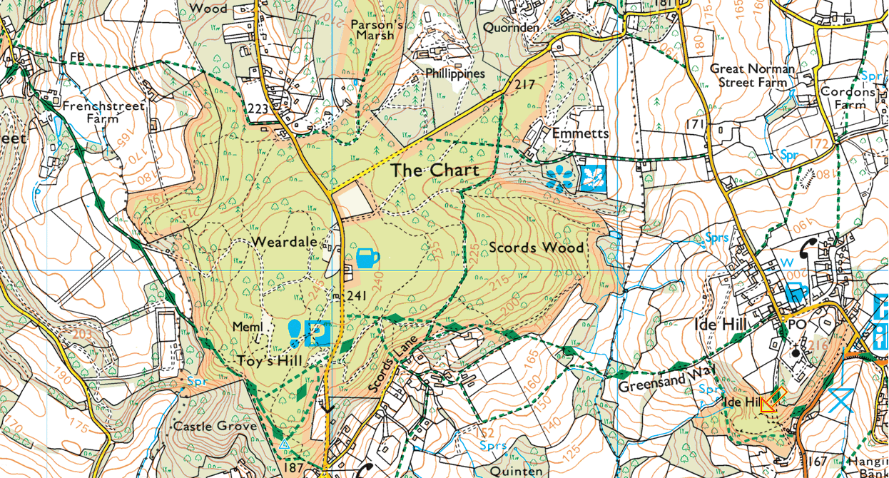
Follow Greensand Way back to Ide Hill via Toys Hill Park at triangle by road here at Ide Hill

