Start heading SW directly from Cricket pavilion
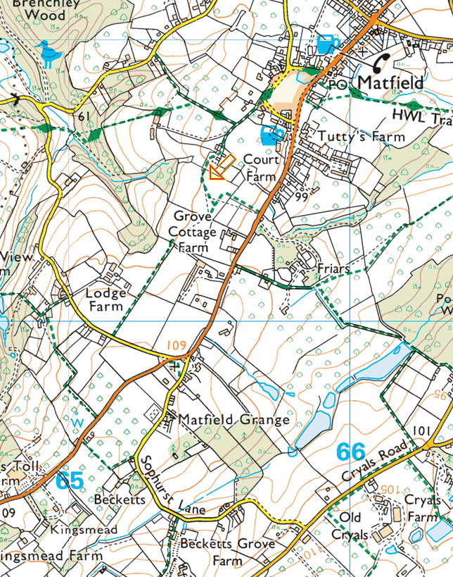
Turn R on road after Lodge Farm, then L into path, and L again
Care crossing main road R and L here onto footpath to Sophurst Lane. Turn R.

Turn R off Sophurst Lane after river
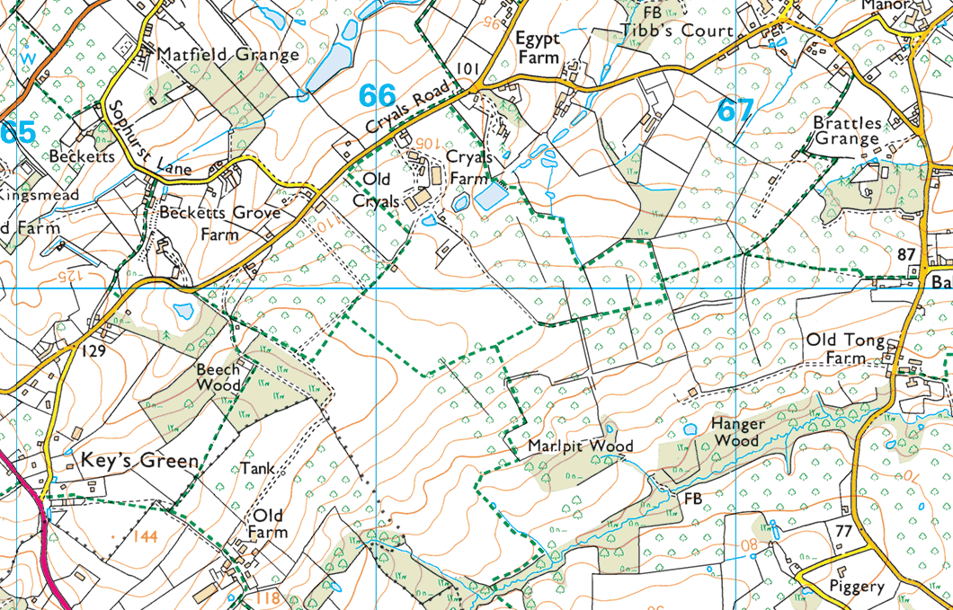At Cryals Road turn L and then bear right into woods on bend Continue zig-zagging eastwards – great views N and S here – and bench for coffee. To here

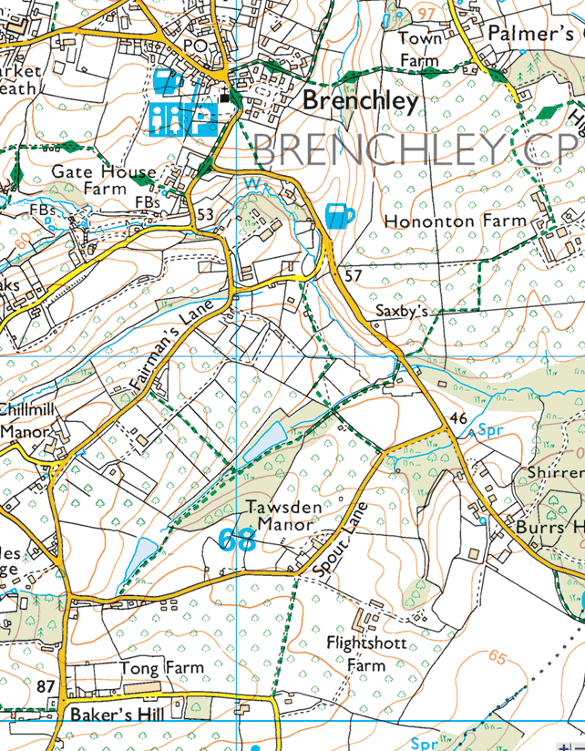
Hit road here at spot height 87 on Baker’s Hill. Turn L and R and bear L to lake. Follow valley NE by lakes, cross road, and through orchards to Hononton Farm. Turn L and up the hill to road. Turn L again through Town Farm to Brenchley – Tricky descent and ascent just before Brenchley. There is a bench on the triangle in from of Bull Inn.

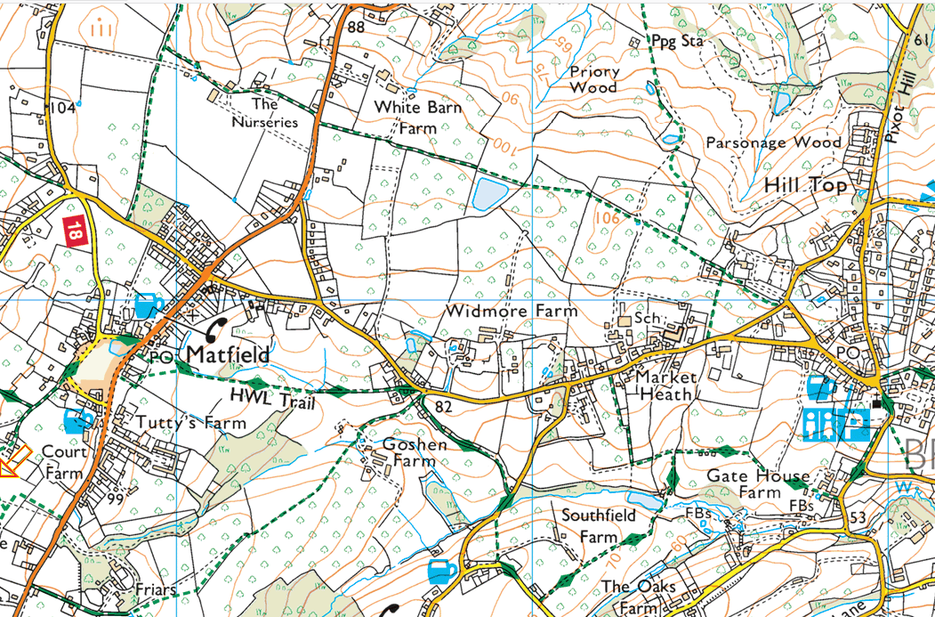
Take road NW from Brenchley and continue in that direction on the path right through to ‘The Nurseries’. After which, turn L to Matfield. At road turn R then L to finish at the green.

