Walk via Leigh
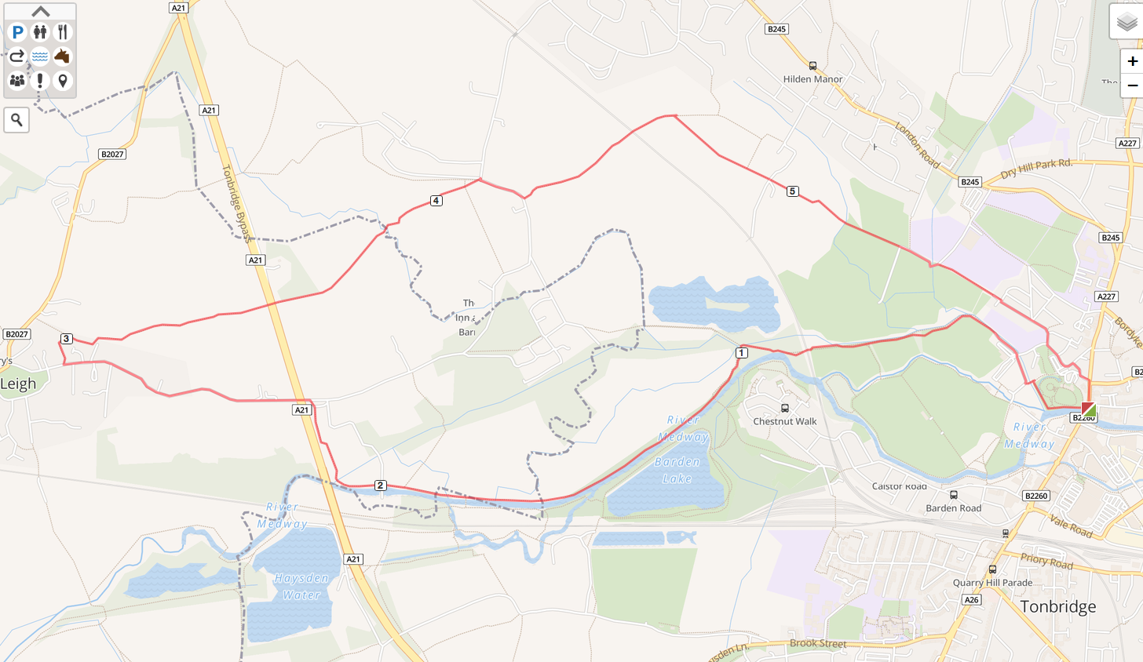

- Start from Big Bridge in Tonbridge follow along foot of Castle towards Swimming Pool.
- At Swimming Pool turn right passing model railway and then onto path passing the rugby club on left. Follow path beside river around edge of Park and under railway bridge heading towards Barden Lake.
- At Junction of Barden Lake or Powder Mills turn left over bridge and then stay on right-hand side of river for just over one mile.
- After passing over the Leigh Barrier and before A21 head away from river to footpath beside A21, follow to Power Mill Lane.
- Follow road under A21 into Leigh village.
- Just past Barnetts Road (on LHS) follow path off to the right between houses, the path zigzags for about 150m.
- At junction turn right passing through a small wood and after 50m the path passes into a field.
- Follow path straight along right hand side of fields, passing through a number of gates and stiles. Note there are four fields and the 4th often has horses grazing.
- After last field the path re-crosses the A21 via a bridge and into a small wood (about 100m) and then into a field.
- Follow the path in a straight line passing close to a cottage in the woods and over a stream (new bridge in good condition) and up hill. Note, although not obvious, the path is also the drive way to the house in the woods.
- The path arrives at the bend of Leigh Road follow the right hand road for 60m and immediately after the only house on LHS follow path (for 20m) through THEIR back garden (it is sign posted).
- Path enters onto an un made lane which you follow to the left passing under the railway line aft 700m
- Approximately 150m into next filed a path heads away to the right (and towards Tonbridge).
- Follow this route as a straight line passing over a private lane, with stiles either side and a further two fields before climbing over a bridge through a hedge onto Tonbridge School sports fields.
- Continue the straight route over the fields onto a short section of tarmac, then via a small bridge into path that exits into Hawden Road near Slade School. Follow road into Stafford Road.
- Now follow route towards Castle car park and then by any route back to the Big Bridge.
- Total Distance 6miles. Duration 2.5hrs. Current walking conditions very wet / deep mud from Leigh to Leigh Road.
- Beware of TRAFFIC ON POWDER MILL LANE AND LEIGH ROAD due to poor visibility for drivers and walkers alike.

